7th May 2020
Year 1
Phonics Y1
Alternative spellings for ‘ch’
Can you write these words: rich, much, future, adventure, catch, stitch – Circle the part in the word which makes the ‘ch’ sound. Which different spellings of the ‘ch’ sound are there?
Can you write these sentences with the ‘ch’ sound in? Remember to use a capital letter, full stop, question mark or exclamation mark and finger spaces!
The witch in the picture is making such a messy mixture.
Watch out! The future will be such a big adventure.
Can you catch the cheeky creature from the kitchen?
English
Design a picnic!
When Gregory and his family were on the beach, they sat down and had a picnic.

Can you design your own menu of things you’d like to eat at a picnic? Here’s an idea of how you could lay it out.

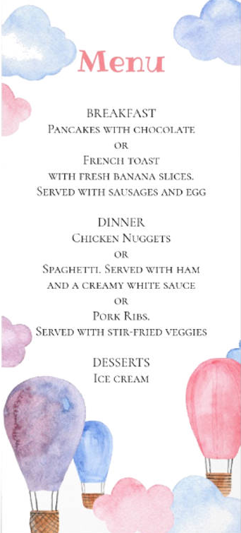

Maths
Number and Place Value
Have a go at this activity where you need to think of a number using the instructions the game gives you!
https://nrich.maths.org/7431

What is the rule?
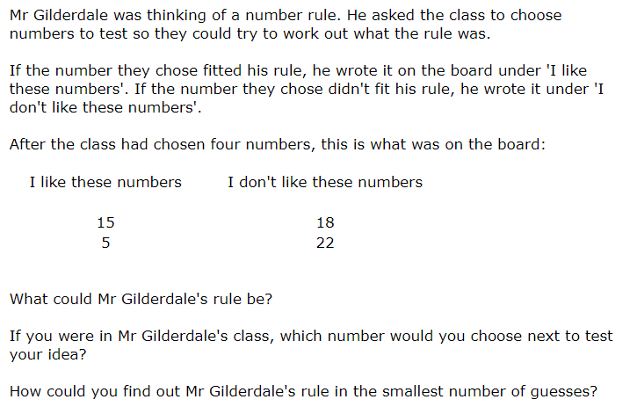
This activity is similar to the questions I ask of you at school like ‘which is the odd one out’. Think about what the numbers have in common in Mr Gilderdale’s lists of numbers he likes and doesn’t like.
Topic: A Tour of Tobago
(Parents: I have watched this video all the way through and wanted to mention that the journalist discusses the name of on the of the bays briefly. The name of the bay is Bloody Bay and the history behind it involved a ‘battle’ so you may want to skip this section of the video (at about 5:13) but other than this, it is a fantastic visual for the children about what the island is like).

Now that you’ve mastered human and physical features and have had a look for some in your local area, this time we are going to look for them in Tobago! Watch the video below to find out exactly what the island looks like, whilst looking for the physical and human features!
https://cdn.theguardian.tv/mainwebsite/2013/10/30/130908BAtobagoWITHLOGO-16x9.mp4

Here are some pictures of some fantastic wildlife I noticed on another video I watched about Tobago, I thought I’d share them with you:
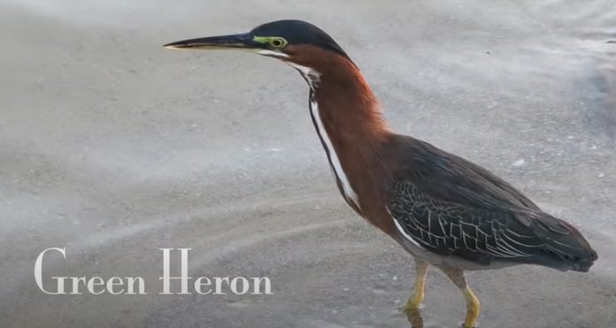

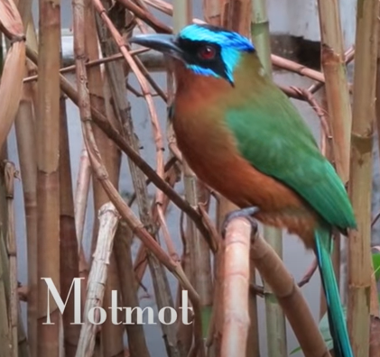
Bamboo plant:

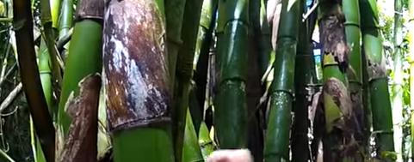

Look at the trunk of this tree!
