Tuesday 5th May Year 3 Extension Challenge
Rachel says that this place value mat represents £4.67  Ones . tenths Hundredths  .  Do you agree? Justify your answer. | Carrie has two pots of money. One with £5.12 and the other contains 71p.  She makes a diagram using place value counters to show her total amount.  +  Ones . tenths Hundredths  .  Is this diagram correct? Explain your thinking.
Martin says that his diagram is the same as Joe’s diagram. Do you agree? Justify your reasoning.  Martin Joe  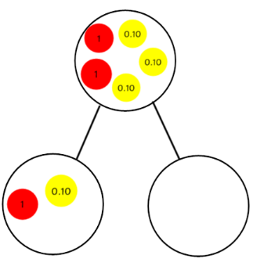  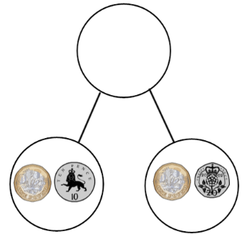 | Spot the mistake!  £  £  Ones . tenths Hundredths  1 . 2 6  2 . 5 4  Katie says that these two amounts equal £3.70.  Is she correct? Explain your reasoning.
Complete the bar model. Write a calculation to prove your answer is correct.  ?  23p £3.12 | Complete the bar model. Write a calculation to prove your answer is correct.  £6.43  99p £2.12 ?
Find the total of these amounts:  £1.87 £4.87 £0.03  What coins would you use to make the total amount? Draw your answer. | Spot the odd one out.  Explain your thinking.  £0.75 £1.15 £0.82  What is total of all three amounts?
Tom has three piles of money. How much has he got altogether?  Write a calculation to show your thinking. | Use place value counters to make £8.23.  Draw your place counters.  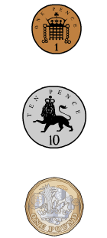  =  =  =
Daisy makes a table of all the coins that she has in her pocket. How much has she got in total?  5  4  3  2  1  10p 20p 50p  Write calculations to prove your answer. | Grace makes a table of all the coins that she has in her pocket. How much has she got in total?  10  8  6  4  2  10p 20p 50p  Write calculations to prove your answer.

Jacob has £1.  He divides his money into 3 piles.  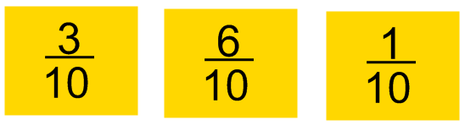  How much is in each pile?  He gave 7 tenths to his friend.  How much did he give away? | Jacob has £100  He divides his money into 3 piles.  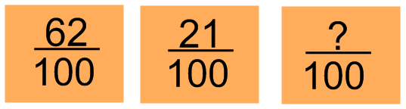  How much is in each pile?  He gave 50 hundredths to his friend.  How much did he give away?
Jacob has £10  He divides his money into 3 piles.  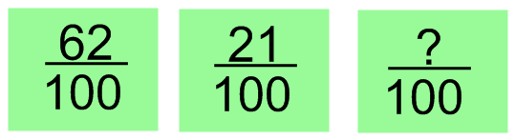  How much is in each pile?  He gave 50 hundredths to his friend.  How much did he give away? | Glen writes this calculation to show the number of coins he has in his piggy bank.  13 x 2p coins  17 x 5p coins  12 x £1 coins  23 x 10p coins  His mum gives him an extra 55p.  How much has he got in total?
Glen writes this calculation to show the number of coins he has in his piggy bank.  12 x 2p coins  11 x 5p coins  2 x £1 coins  3 x 10p coins  His mum gives him an extra 25p.  How much has he got in total? | Gemma and Aysha bought these apples.  Apples cost 25 p each. Gemma bought  four times as many muffins as Aysha.  How much did they each spend?  How much did they spend altogether?  How much more did Gemma spend than  Aysha?

