Friday 12th June 2020
Reception
Phonics  English | Grab a Giggling Grapheme: https://www.phonicsplay.co.uk/member-only/GrabAGigglingGrapheme.html  Listen to the sound and see if you can remember the way that each phoneme looks!  Writing words in sentences  Today you are going to create your very own Zig Zag Book!  Watch this video showing you how to make yours: https://www.youtube.com/watch?v=21qi9ZcQVto  Can you write about the sea in your book? Tell me about the things the sea can do, the colour, what it feels like, what lives in the sea. Remember to draw a picture on each page too!  This week, our Theme has been Seaside Summer Holidays. In At the Beach, the family took their caravan and stayed at a campsite whilst they were at Crabby Spit.  Your mission for today is to design your very own Holiday Campsite! It can have whatever you’d like it to have! There might be: A swimming pool, a theme park, unlimited ice cream stalls or free sun cream!  You could draw your design, build your design using bricks/lego or you could create it in a shoe box! I’d love to see some signs for each part of your campsite, you could even design a leaflet to persuade people to visit and possibly include the prices of how much it would cost to stay there too!
Maths | Listen to Tiddler by Julia Donaldson being read here: https://www.youtube.com/watch?v=pBRT5vsfE3U  Can you spot the clocks in the book? Can you read the times on the clocks?  Clock Hunt  Remind yourselves of O’Clock times with this video: https://open.online.clickview.co.uk/libraries/categories/26204561/videos/13078019/o-clock-on-analogue-clocks  (Adults, print/draw and hide the clocks around the house/room/garden and ask your child to tick off the times they can see on their checklist.)  Can you make your own clock (or use one you have already made a few weeks ago) to show times to half past?  I wonder if you can write the time next to the clock too (half past two etc.)?
Topic | For your English lesson, you were asked to design your own campsite, this afternoon you are going to design and create your very own seaside town! There could be bouncy castles, doughnut stalls, submarines to hire! It’s up to you!  Use the pictures of other seaside towns to help you design your seaside town!  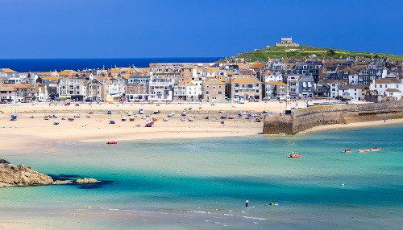  Think about whether you are going to charge people to visit and have a go at each activity or will people be allowed to use them for free?  What will you call your town? Have a go at creating your own sign to show people they have arrived!

