It was the 3rd January and we were ready for our first day of exploring Scotland. We went down to the restaurant for some breakfast, I had some croissants and some delicious grapefruit (my favourite). After breakfast, we drove to a place called Loch Lomond.
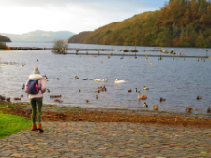

It was very cold so we made sure we were prepared for the weather with our fluffy jackets, walking boots, gloves and hats! We walked around the loch (a loch is a large area of water in Scotland that is completely or almost completely surrounded by land) and saw swans and ducks swimming in the ice cold water! We spotted a little island in the middle of the loch with some houses on it! We wondered if people lived there or if people could stay there for their holidays. As we finished our walk, we came across a little stream running across the path with stepping stones in it! Here’s a picture of us walking over it!

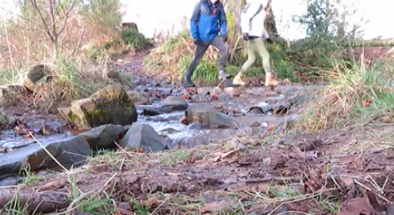

Afterwards, we headed to Queen Elizabeth Forest Park which is a little bit like Thetford Forest. It was really quiet with very few people so we stopped for a bite to eat (we had paninis) and then headed off for a walk up to the top of the hill. It was a lot higher than we thought it would be, but we didn’t mind, we really enjoy walking! The sunshine beamed through the forest and made it feel quite warm which was nice.
On our way home we stopped at a little village called Culross which has been used for various TV shows and movies! We walked to Culross Palace but unfortunately it was closed. For dinner we went to Wagamamas (Ryan’s favourite place to eat) for his birthday dinner. He was happy and so was I, it felt nice to sit down for a few hours with some delicious food!
On the final day of our Edinburgh trip, we walked up Arthur’s Seat (which is a big hill in Edinburgh) and saw some remarkable views from the top! Afterwards we drove to a place called New Lanark. It is a village captured in time (this means it hasn’t changed for lots of years). We stopped for a little snack (I had a delicious cherry scone) and then we went for a walk along the Waterfall walk – where we saw lots of waterfalls!
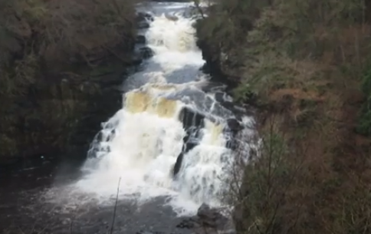

And there we have it, our Edinburgh adventure. We had a lovely time and would love to go back and explore even more! I hope you enjoyed reading about our trip.

