**Revising oo, ew, ue, u_e**

[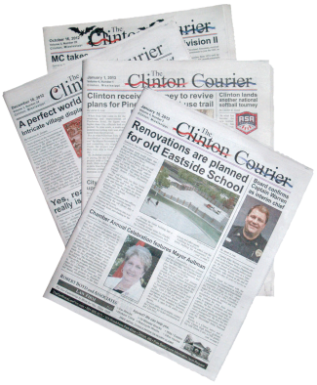](http://www.google.co.uk/url?sa=i&rct=j&q=&esrc=s&source=images&cd=&cad=rja&uact=8&ved=0CAcQjRw&url=http%3A%2F%2Fwww.newsouthernview.com%2Fpages%2Fnsvcs_newspaper_design.html&ei=L_ZxVZTaJueY7gaAz4DACw&bvm=bv.95039771,d.ZGU&psig=AFQjCNHGTvmWItmc9Bk-UYD98PvWOSTi2w&ust=1433618348544682)[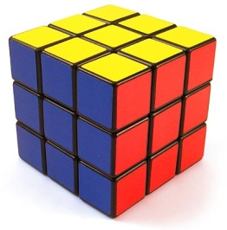](http://www.google.co.uk/url?sa=i&rct=j&q=&esrc=s&source=images&cd=&cad=rja&uact=8&ved=0CAcQjRw&url=http%3A%2F%2Fwww.thinkgeek.com%2Fproduct%2F69fe%2F&ei=6vRxVeaNF-u67gbN44OQAg&bvm=bv.95039771,d.ZGU&psig=AFQjCNGuwsOuxXs4P6NwBLVuba2enbwv2Q&ust=1433618023166611)Can you sound out the word and match it to a picture?

blue

[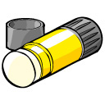](http://www.google.co.uk/url?sa=i&rct=j&q=&esrc=s&source=images&cd=&cad=rja&uact=8&ved=0CAcQjRw&url=http%3A%2F%2Fwww.cliparthut.com%2Fglue-stick-clipart.html&ei=SPVxVa_MJ6SU7Aam4IFw&bvm=bv.95039771,d.ZGU&psig=AFQjCNGFoJcbAYvq8eNX00xL5hrVwYPmyw&ust=1433618112633892)broom

[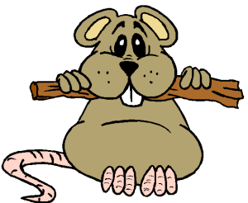](http://www.google.co.uk/url?sa=i&rct=j&q=&esrc=s&source=images&cd=&cad=rja&uact=8&ved=0CAcQjRw&url=http%3A%2F%2Fcarrierubin.com%2F2012%2F09%2F13%2Fmr-nasty-pants-gets-bested-by-you-and-haiku%2F&ei=zvRxVbW_IOTZ7gbji4PQBg&bvm=bv.95039771,d.ZGU&psig=AFQjCNFiS4w44aKTJRAKms87_EZ9C_Af_A&ust=1433617995658961)chew

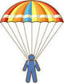cube

[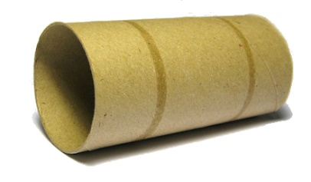](http://www.google.co.uk/url?sa=i&rct=j&q=&esrc=s&source=images&cd=&cad=rja&uact=8&ved=0CAcQjRw&url=http%3A%2F%2Fwww.therabbithouse.com%2Fblog%2F2011%2F02%2F10%2Fcardboard-tube-toys-part-3%2F&ei=4_ZxVf-ZNOKt7AaMsoDIAg&bvm=bv.95039771,d.ZGU&psig=AFQjCNHYKF4DBvIk9h18U_gh5-6KKsHFdg&ust=1433618521342427)flute

[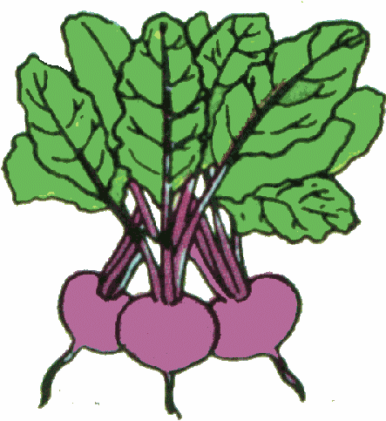](http://www.google.co.uk/url?sa=i&rct=j&q=&esrc=s&source=images&cd=&cad=rja&uact=8&ved=0CAcQjRw&url=http%3A%2F%2Fwww.clipartpanda.com%2Fclipart_images%2Fbeetroot-gif-24781339&ei=s_ZxVYjgDvCR7Ab9q4GQAQ&bvm=bv.95039771,d.ZGU&psig=AFQjCNEOhZPBZT1LkNZh6Q8XkUM2yjn58A&ust=1433618481742960)glue

[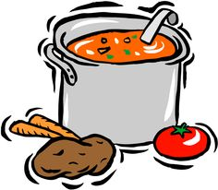](https://www.google.co.uk/url?sa=i&rct=j&q=&esrc=s&source=images&cd=&cad=rja&uact=8&ved=0CAcQjRw&url=https%3A%2F%2Fwww.pinterest.com%2Fmmmerrill%2Fsoups%2F&ei=afZxVfWlKMqr7AaqtIPYCQ&bvm=bv.95039771,d.ZGU&psig=AFQjCNGdv_t7ABpTAUzC-TagoR1qZRNSIQ&ust=1433618401880917)newspaper

[](http://en.wikipedia.org/wiki/Blue)stew

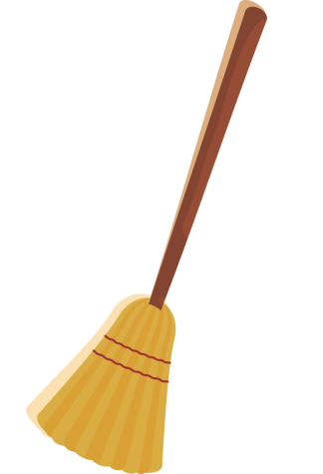parachute

[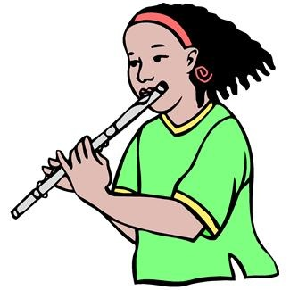](https://www.google.co.uk/url?sa=i&rct=j&q=&esrc=s&source=images&cd=&cad=rja&uact=8&ved=0CAcQjRw&url=https%3A%2F%2Fwww.pinterest.com%2Fmusicfacts%2Fmusic-clip-art%2F&ei=DvVxVdaUJ6LQ7AaLwYBw&bvm=bv.95039771,d.ZGU&psig=AFQjCNGr3SVWvpx9WQbUJ-8lT1TnwPEKzw&ust=1433618056782423)beetroot

tube