Hedgehog Class Home Learning Wednesday 1st April 2020

English/Phonics

CGP Book – next 2 pages please

Phonics – Mr Mc – Day 4 – revise the digraphs ar or ur
https://www.youtube.com/watch?v=LuCnVuWSKqs

Can you read the following sentences and highlight the digraphs ar, or, ur? You might even find some more digraphs hiding!

I will go in the car to the park.
Can you turn the big turnip over?
I went for a long walk in the storm.

Writing: can you tell your child a sentence to write using the digraphs ar, or, ur? You could try include some of the tricky words i.e.
My dog will bark if there is a storm and his fur will get wet.
You may decide to try forming the digraphs using Mr Mcs ideas!

Maybe you could now play some of the games that Mr Mc has shown you. Do you have a remote control car or robot that can park/stand on different words that you can then read?

Maths

CGP Book – next 2 pages please

White Rose Maths Website
Week 1 – day 4 – Number or Shape Hunt
Recap the names for the common 2D shapes i.e. rectangle, square, circle, triangle. Your child may also know semi-circle, hexagon, pentagon, diamond
Can they remember any of the names for 3D shapes i.e. sphere, cuboid, cube, cone, cylinder?
The Singing Walrus looks at cones, cylinders, spheres and cubes (not cuboids)
https://www.youtube.com/watch?v=guNdJ5MtX1A

Go on a shape and number hunt. Take pictures of the 2D and 3D shapes you find.

For related topic/craft activities:
Play games that involve using dice. If you roll a dice count how many spots. Roll again. How did the number change? Is it a bigger/smaller number than before? What is the most spots you can have if you roll 3 dice?
Can you draw round a plate and cut the circle out? Fold the circle in half, open it out and cut on the fold line so you have two semi-circles. Can you make party hats from the semi-circles? Will they fit you? If not, can you find perhaps a cuddly toy that they will fit? How big would the circle have to be to make yourself a party hat to wear??? Would love to see pictures of you wearing party hats!

Collective Worship

Can your child tell you about when and where they may have seen a cross? Why do they think there is a cross on a hot cross bun? When do we eat hot cross buns? Could they find out why?

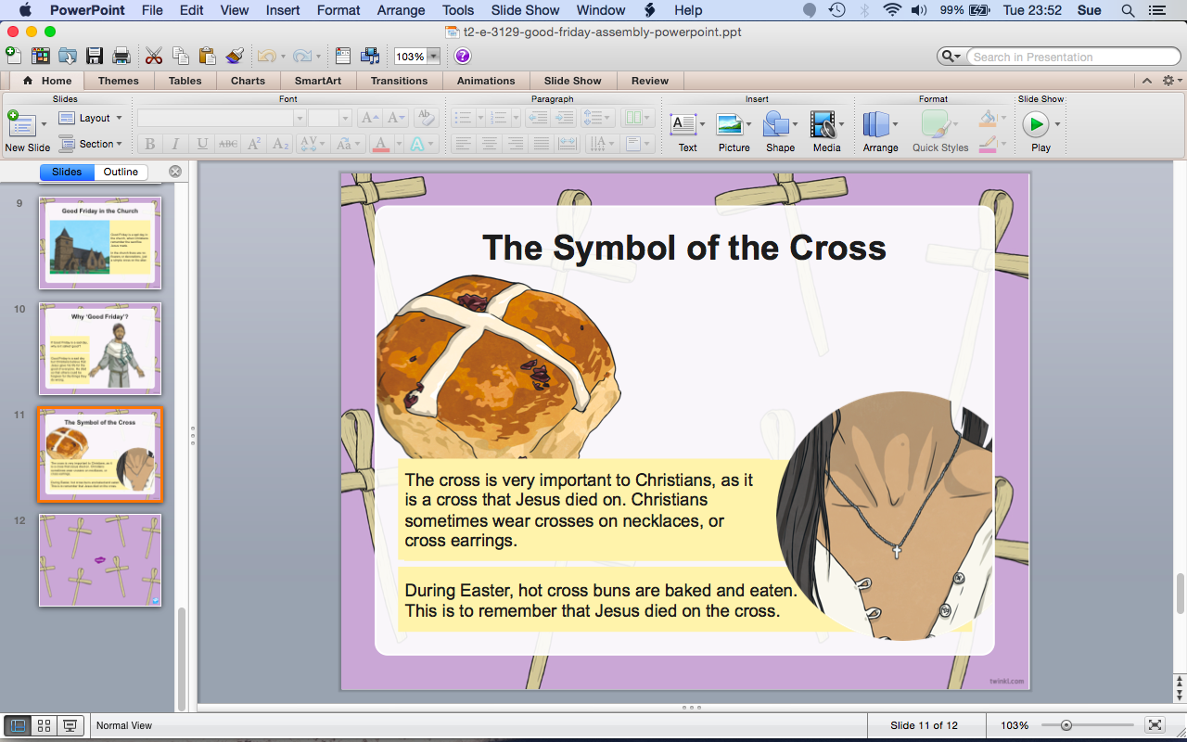

Have you all have a good and safe day.

