Please copy out the poem Planet Blatt using the cursive handwriting style.

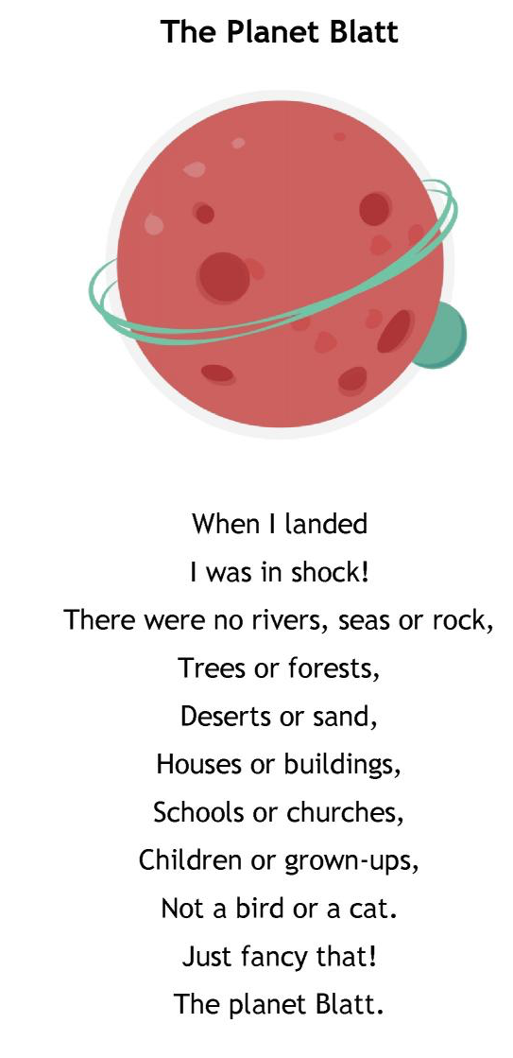

The Planet Blatt

When I landed …

Remember – you do not join a capital letter to the next letter.

