12th May 2020
Reception
Phonics: Missing Phonemes Game
Write the following words with spaces in the middle for the missing phonemes, like this: 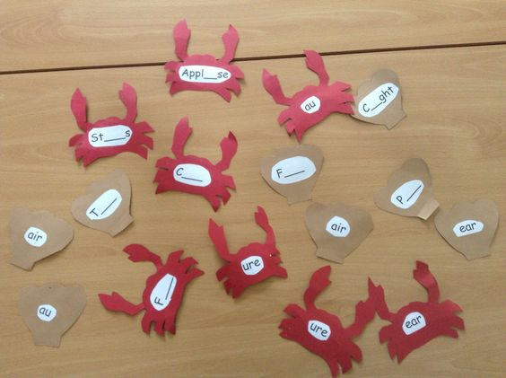

T__n (town)
D__n (down)
G___ (gear)
f___ (fear)
B___d (beard)
S____ (sure)
C___ (cure)
P____ (pure)
Sec___ (secure)

Write the sounds ‘ure’ ‘ow’ ‘ear’ on separate cards for the children to match the correct phoneme with the word.
English: Today I’d like you to look through some photos of holidays or days out or even if you moved house. If you have a group of photos linked to one event, see if you can put them in order! Talk to your family about the trip and see if they can remind you what happened if you’ve forgotten!
Maths:
Half Past
https://open.online.clickview.co.uk/libraries/videos/13078078/analogue-clocks-telling-time-to-half-past
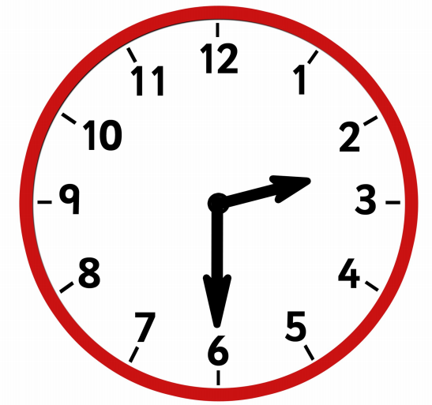
This clock shows the time half past 2, when the long hand is on the number 6, this means it is half past. Can you see the little hand has moved past the number 2 but isn’t on the number 3 yet? That means it is half past 2!

Can you make your own clock using a paper plate, or using some sticks you find in the garden as hands on a clock to show some other half past times?

If you are confident, you could try a matching activity like the one attached, Can you match the worded times with the right clock? Don’t worry, adults can help you read the times!
Topic: What grows where?

Find out about the different fruits which are grown in Tobago, this video shows a few: https://www.youtube.com/watch?v=HQ_NRal_tKA

Do any of them look similar to any fruits we see in the United Kingdom?

Make a poster showing the different fruits grown in Tobago.

Learn about some of the fruit grown in the United Kingdom here: https://www.bbc.co.uk/teach/class-clips-video/william-whiskerson-orchard-fruit/z6xtscw
Can you name any other fruits we can grow?

