Monday 1st June 2020
Reception
English | Our Topic theme this week is all about different types of transport, so this week in English we are going to be looking at a story about a very Naughty Bus..  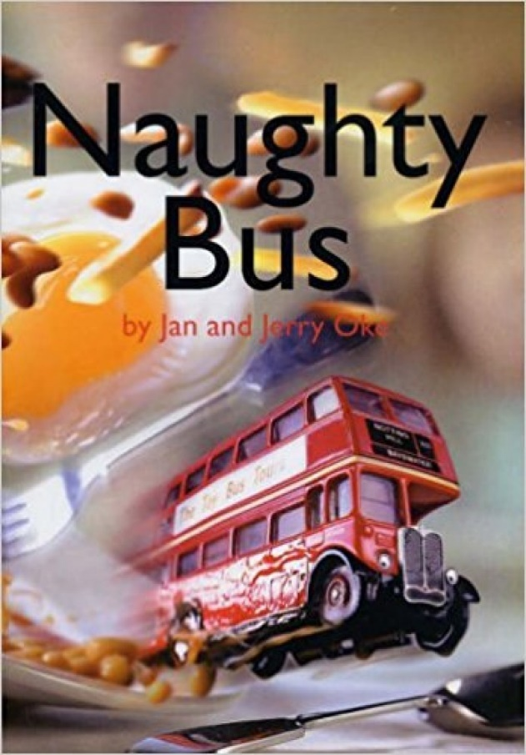  Can you recreate the front cover using a different vehicle, you could draw a Terrible Car or a Horrid Bicycle! What pictures could you draw around your vehicle to make it look like it’s up to no good?
Maths | Doubling  Have a go at these activities to remind you what doubles are: https://kids.classroomsecrets.co.uk/resource/reception-doubling-game/  https://kids.classroomsecrets.co.uk/resource/reception-doubling-numbers-game/  When you double a number, the answer always gets bigger!  Roll a dice and see what it lands on. Then..  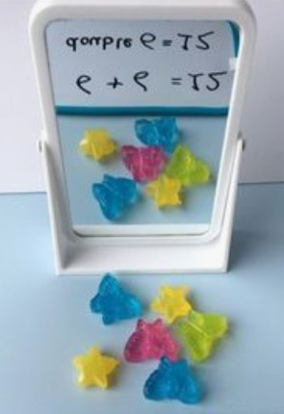  Use a mirror and a group of objects to help you find the answer to doubling numbers!  Make a doubling flap book to record what you found out!  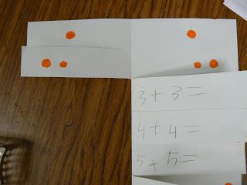
Topic | This week we are going to be looking at how different types of transport have changed over time.  First off, make a list/draw a picture of each type of transport you can think of.  Reception: Draw pictures & label 4 with words  Can you sort the types of transport into different categories (examples could be: amount of wheels, if they have an engine, if they produce smoke/steam).  What type of transport do you think was the first to be ‘invented’?  Discuss walking and then going by horse, horse and cart. Explain that as far back as caveman times, when humans first came to be on this earth (after the dinosaurs), we discovered fire and worked out how to use simple tools and plant things, etc. Thousands of years later we invented the wheel. This has led to transport. When early humans created the wheel, it would have been a stone wheel in the stone age, then wood and metal wheels. We had the wheel for simple carts thousands of years ago.  Wheels  Your challenge: To make your own wheel! Use resources you have available in the house and see how far it rolls!  Bonus points if your wheel has spokes and tread around the outside! 